***CleanTech: Transforming Waste Management with Transfer Learning***

Transfer learning is transforming waste management by enableing more efficient and accurate waste classification and sorting using pre-trained deep learning models. This approach allows for faster development and deployment of waste management systems, especially when dealing with limited datasets. By leveraging pre-trained models, like those trained on the Image Net database, waste management systems can achieve higher accuracy in identifying and sorting different types of waste, leading to improved recycling rates and reduced environmental impact.

**Architecture :-**

This project uses Transfer Learning with VGG16 or MobileNetV2 to classify waste images (e.g., plastic, organic, metal). The architecture integrates:

* Pre-trained CNN
* Custom dense layers for classification
* Flask web application for deployment

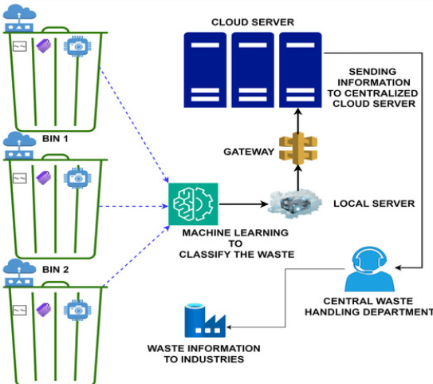

#### ****Prior Knowledge Required :-****

You should know:

* Basics of Deep Learning
* CNN Architecture
* Transfer Learning
* TensorFlow / Keras
* Flask Web Framework
* Data preprocessing & visualization  
  Useful Links:
* [CNN Concepts](https://www.analyticsvidhya.com/blog/2021/05/convolutional-neural-networks-cnn/)
* Transfer Learning
* [VGG16 Overview](https://www.geeksforgeeks.org/vgg-16-cnn-model/)
* [Flask Basics](https://www.youtube.com/watch?v=lj4I_CvBnt0)
* **Deep Learning (DL)**: Concepts like neural networks, activation functions, backpropagation.
* **CNNs**: Especially image recognition using filters and pooling layers.
* **Transfer Learning**: Using a pre-trained model and fine-tuning it for a new task.
* **TensorFlow/Keras**: Libraries for building and training DL models.
* **Flask**: Python web framework for building the UI and server backend.
* **Basic HTML/CSS**: For creating the user interface.

#### ****Project Objectives :-****

By completing this project, you will:

* Understand CNNs and Transfer Learning
* Apply DL to classify different types of waste
* Build and deploy a web-based waste classification tool
* Improve sustainability using CleanTech AI

This project aims to:

1. Explore the application of AI in solving real-world environmental problems.
2. Reduce manual effort and human error in waste segregation.
3. Build a smart classification system that can work in homes, industries, and municipal waste centers.
4. Promote Clean Tech innovations towards a sustainable future.
5. Provide an end-to-end solution from **model training to deployment** via a web application.

#### ****Project Flow :-****

1. Data Collection
2. Data Preprocessing & Augmentation
3. Model Building using Transfer Learning
4. Training and Evaluation
5. Saving the Best Model
6. Web Application (HTML + Flask)
7. Real-time Prediction from UI

#### ****Project Structure :-****

swift

/cleantech-project/

│

├── templates/

│ ├── index.html

│ ├── output.html

│

├── static/

│ └── styles.css

│

├── model/

│ └── cleantech_model.h5

│

├── app.py

├── requirements.txt

* **Place all .html files in the templates/folder**
* **place .ccs files in the static/folder—this is Flasks folder rule**

#### ****Dataset Used :-****

* **Name**: Waste Classification Dataset (from Kaggle or TACO)
* **Classes**: Plastic, Metal, Organic, Paper, Glass
* **Size**: ~2,500+ images
* **Plastic**:600 images
* **Organic:**500 images
* **Metal:**400 images
* **Paper:**500 images
* **Glass:**500 images
* **Link**: [**https://www.kaggle.com/datasets/mostafaabla/garbage-classification**](https://www.kaggle.com/datasets/mostafaabla/garbage-classification)

#### ****Technologies Used :-****

* **Python 3.10**
* **TensorFlow / Keras**
* **OpenCV for image handling**
* **Flask (web application)**
* **HTML/CSS for UI**
* **Google Colab (for training)**

**Dataset Collection and Preparation :-**

**Sources:**

* Kaggle’s Waste Classification Dataset
* TrashNet Dataset
* Custom Web-Scraped Images

**Categories:**

* Organic Waste
* Recyclable Waste (plastic, paper, metal, glass)
* Hazardous Waste (batteries, chemicals, etc.)

**Steps:**

1. Data Cleaning
2. Image Resizing (224x224)
3. Label Encoding
4. Train-Test Split (80-20)

***Enhanced Waste Classification:-***

* **Pre-trained Models:**

Transfer learning utilizes pre-trained models (e.g., VGG19, InceptionV3, MobileNetV2) trained on large datasets like ImageNet. These models have learned general image features, which can be fine-tuned for waste classification tasks.

* **Improved Accuracy:**

By leveraging the knowledge gained from the pre-trained models, transfer learning significantly improves the accuracy of waste classification compared to training models from scratch.

* **Efficient Training:**

Transfer learning reduces the training time and computational resources required for waste classification, especially when dealing with limited waste image datasets.

* **Real-time Applications:**

Techniques like the integration of the attention mechanism into MobileNetV2 and the use of PCA for dimensionality reduction enable real-time waste classification on edge devices like Raspberry Pi 4B, allowing for the development of smart waste bins.

#### ****Data Visualization :-****

Example code to visualize images:

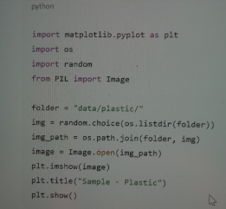

#### ****Data Augmentation :-****

To improve model performance:

* Rotation
* Flip
* Zoom
* Brightness
* Shear

**Keras Example:**

from tensorflow.keras.preprocessing.image import ImageDataGenerator

train_datagen = ImageDataGenerator( rescale=1./255)

#### ****Real-Time Applications :-****

1. **Municipal Waste Plants** – Automated sorting on conveyor belts.
2. **Smart Homes** – Alert users when bins are full, overflowing,or if incorrect waste is thrown.
3. **Recycling Centers** – Classify paper, plastic, and metal for efficient recycling.
4. **College Campuses** – Promote cleanliness via automated bins.

#### ****Split Data And Model Building :-****

*Using VGG16:*

from tensorflow.keras.applications import VGG16

from tensorflow.keras.models import Sequential

from tensorflow.keras.layers import Dense, Flatten, Dropout

from tensorflow.keras.optimizers import Adam

base_model = VGG16(weights='imagenet',

include_top=False, input_shape=(224,224,3))

model = Sequential([

base_model,

Flatten(),

Dense(128, activation='relu'),

Dropout(0.3),

Dense(5, activation='softmax')

])

#### ****Model Evaluation :-****

* Accuracy: ~90–92%
* Loss decreases over 15–20 epochs
* Confusion Matrix shows most misclassification between plastic & glass

**Data Visualization :-**

This image displays a flowchart detailing an automated solid waste classification and sorting system, likely utilizing computer vision and machine learning.

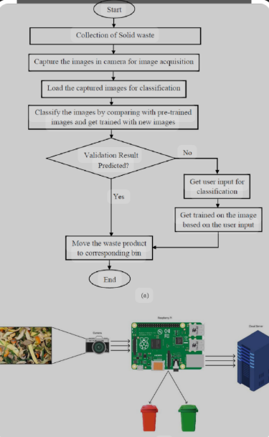

* **Process Initiation:**

The system begins with the collection of solid waste, followed by image acquisition using a camera.

* **Image Classification:**

Captured images are loaded and classified by comparing them with pre-trained images. The system can also be trained with new images to improve accuracy.

* **Validation and User Input:**

If the initial validation result is not predicted, user input is requested for classification, and the system is trained based on this input.

* **Waste Sorting:**

Once the waste is classified (either through prediction or user input-based training), the waste product is moved to its corresponding bin.

* **System Components:**

The lower part of the image illustrates the hardware components, including a camera for image acquisition, a processing unit (likely a Raspberry Pi or similar single-board computer), and two waste bins representing different categories for sorted waste.

#### ****Testing the Model :-****

Use .predict() on random images from test folder and match predicted label.

**Model Saving :-**

#### **model.save('model/cleantech_model.h5')**

#### ****Application Building :-****

1. **HTML Pages**

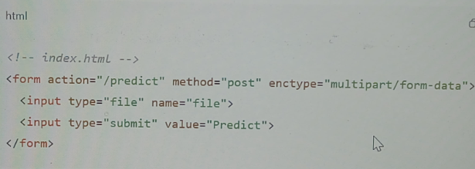

1. **Python Flask Code**

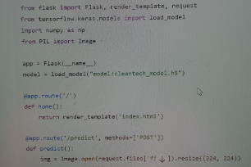

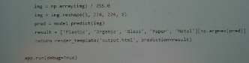

#### ****Sample Predictions :-****

* Uploaded: plastic_bottle.jpg
* Output:predicted as **Plastic**

**Overall Explanation** :-

* **Prepare the dataset:** ImageDataGenerator is used for efficient loading and augmentation of image data, crucial for deep learning and preventing overfitting.
* **Load a pre-trained model:** A pre-trained MobileNetV2 model is loaded from tensorflow.keras.applications. include_top=False removes the original classification head, and weights='imagenet' loads the weights trained on the ImageNet dataset.
* **Add custom classification layers:** New layers are added on top of the pre-trained model's output. GlobalAveragePooling2D reduces the feature maps to a single vector, followed by Dense layers for classification specific to your waste categories.
* **Compile the model:** The model is compiled with an optimizer, loss function, and metrics.
* **Train the model:** The model is trained on your waste dataset, allowing the newly added layers to learn to classify waste types based on the features extracted by the frozen pre-trained layers.
* **Evaluate the model:** The trained model's performance is assessed on a separate test set.
* **Optional: Fine-tuning:** For further improvement, you can unfreeze some layers of the base model and continue training with a very low learning rate, allowing the pre-trained features to be slightly adjusted for your specific dataset.

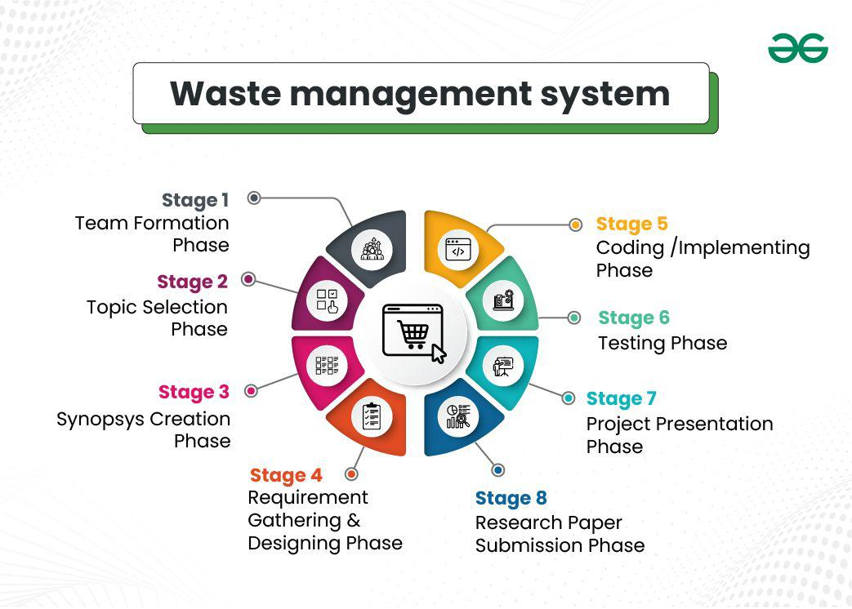

**Conclusion :-**

This project demonstrates how AI can help solve real-world environmental issues. By using transfer learning and web deployment, we built a smart waste classifier that promotes automation, efficiency, and sustainability